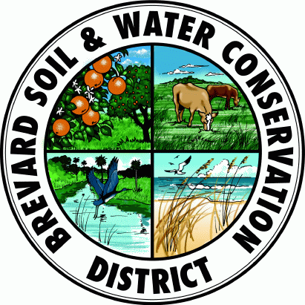
BREVARD SOIL & WATER CONSERVATION DISTRICT

Supervisor’s Monthly Meeting

Meeting Information

Date: 07/08/2026

Time: 4:00 PM

Location: UF Extension Office, 3695 Lake Dr., Cocoa, Florida
Guests / Staff: Beth Shephard, UF/IFAS Brevard County Extension Director
Morgan Yoder, UF/IFAS Livestock Agent
Keith Newman, UF/IFAS Agricultural Program Assistant
Derrick Wyle, USDA NCRS, District Conservationist

Agenda

- Call to Order

- Treasurer’s Report

- Approval of April’s Minutes

- District Conservationist Update

- UF/IFAS Extension Update

- Old Business:
  - Website update.

- New Business:

- Additions to Agenda / Open Discussion:
  - Discussion of work agreement with SJWMD.
  - Discussion of current election cycle.

Next Meeting

4:00 PM, October 14th, 2026, at UF Extension Office, 3695 Lake Dr., Cocoa, Florida

Other Notes or Information

